**Empowering Western Odisha’s Local Economy & Tourism: HERITAGE YATRI - Your All-in-one Heritage Guide and One Stop Solution for All Travel Concerns**

**Category**: Start-Up and Business Ideas

**Why Heritage Yatri?**

**The Problem:**

Tourists visiting new state, let’s say Odisha, often struggle with fragmented and unreliable information about attractions, local food, accommodations, transport options, and emergency services. They are forced to use multiple apps to book hotels, locate tourist spots, find local cuisines, contact transport providers, and access emergency services, leading to confusion and inefficiency. This inconvenience affects the overall travel experience and limits the reach of local businesses.

**The Solution:**

“**HERITAGE YATRI**” is a comprehensive travel solution app that unifies all essential services into a single platform. It serves as a smart companion that not only provides detailed tourist information but also enables users to book hotels, transportation (including intercity train, flight, and bus tickets), explore local cuisines, contact verified local transport providers, and access emergency services. By collaborating with third-party service providers and government tourism portals, HERITAGE YATRI simplifies and enriches the travel experience while supporting the local economy.

**Feasibility:**

HERITAGE YATRI is designed to be both practical and transformative in its implementation. By leveraging existing technologies and strategic partnerships, the application aims to bridge the digital gap in the tourism industry. The feasibility of HERITAGE YATRI lies in its use of mature development frameworks and the growing digital infrastructure in India.

**• Technical Feasibility**: Uses Flutter or React Native for app development, integrating APIs for maps, hotel listings, transport, ticket booking, and emergency services.

**• Data Feasibility**: Sources data from government tourism boards and crowd-sourcing.

**• Operational Feasibility**: Initial deployment in Balangir, Odisha targeting key tourist hubs with partnerships from local stakeholders.

**Scalability:**

Scalability is supported through modular design and an API first approach, allowing for seamless integration of new services, cities, and languages.

**• Geographic Expansion**: Scalable to cities across Odisha and India.

**• Service Expansion**: Addition of AR-based navigation, smart itinerary planner, and multilingual support.

**Impact:**

The potential impact of the app is multifaceted benefiting tourists, local businesses, and regional economies alike.

**• Tourists**: Increased convenience, safety, and travel efficiency.

**• Local Economy**: Boost in local business and tourism income.

**• Government**: Support for tourism promotion and digital infrastructure development.

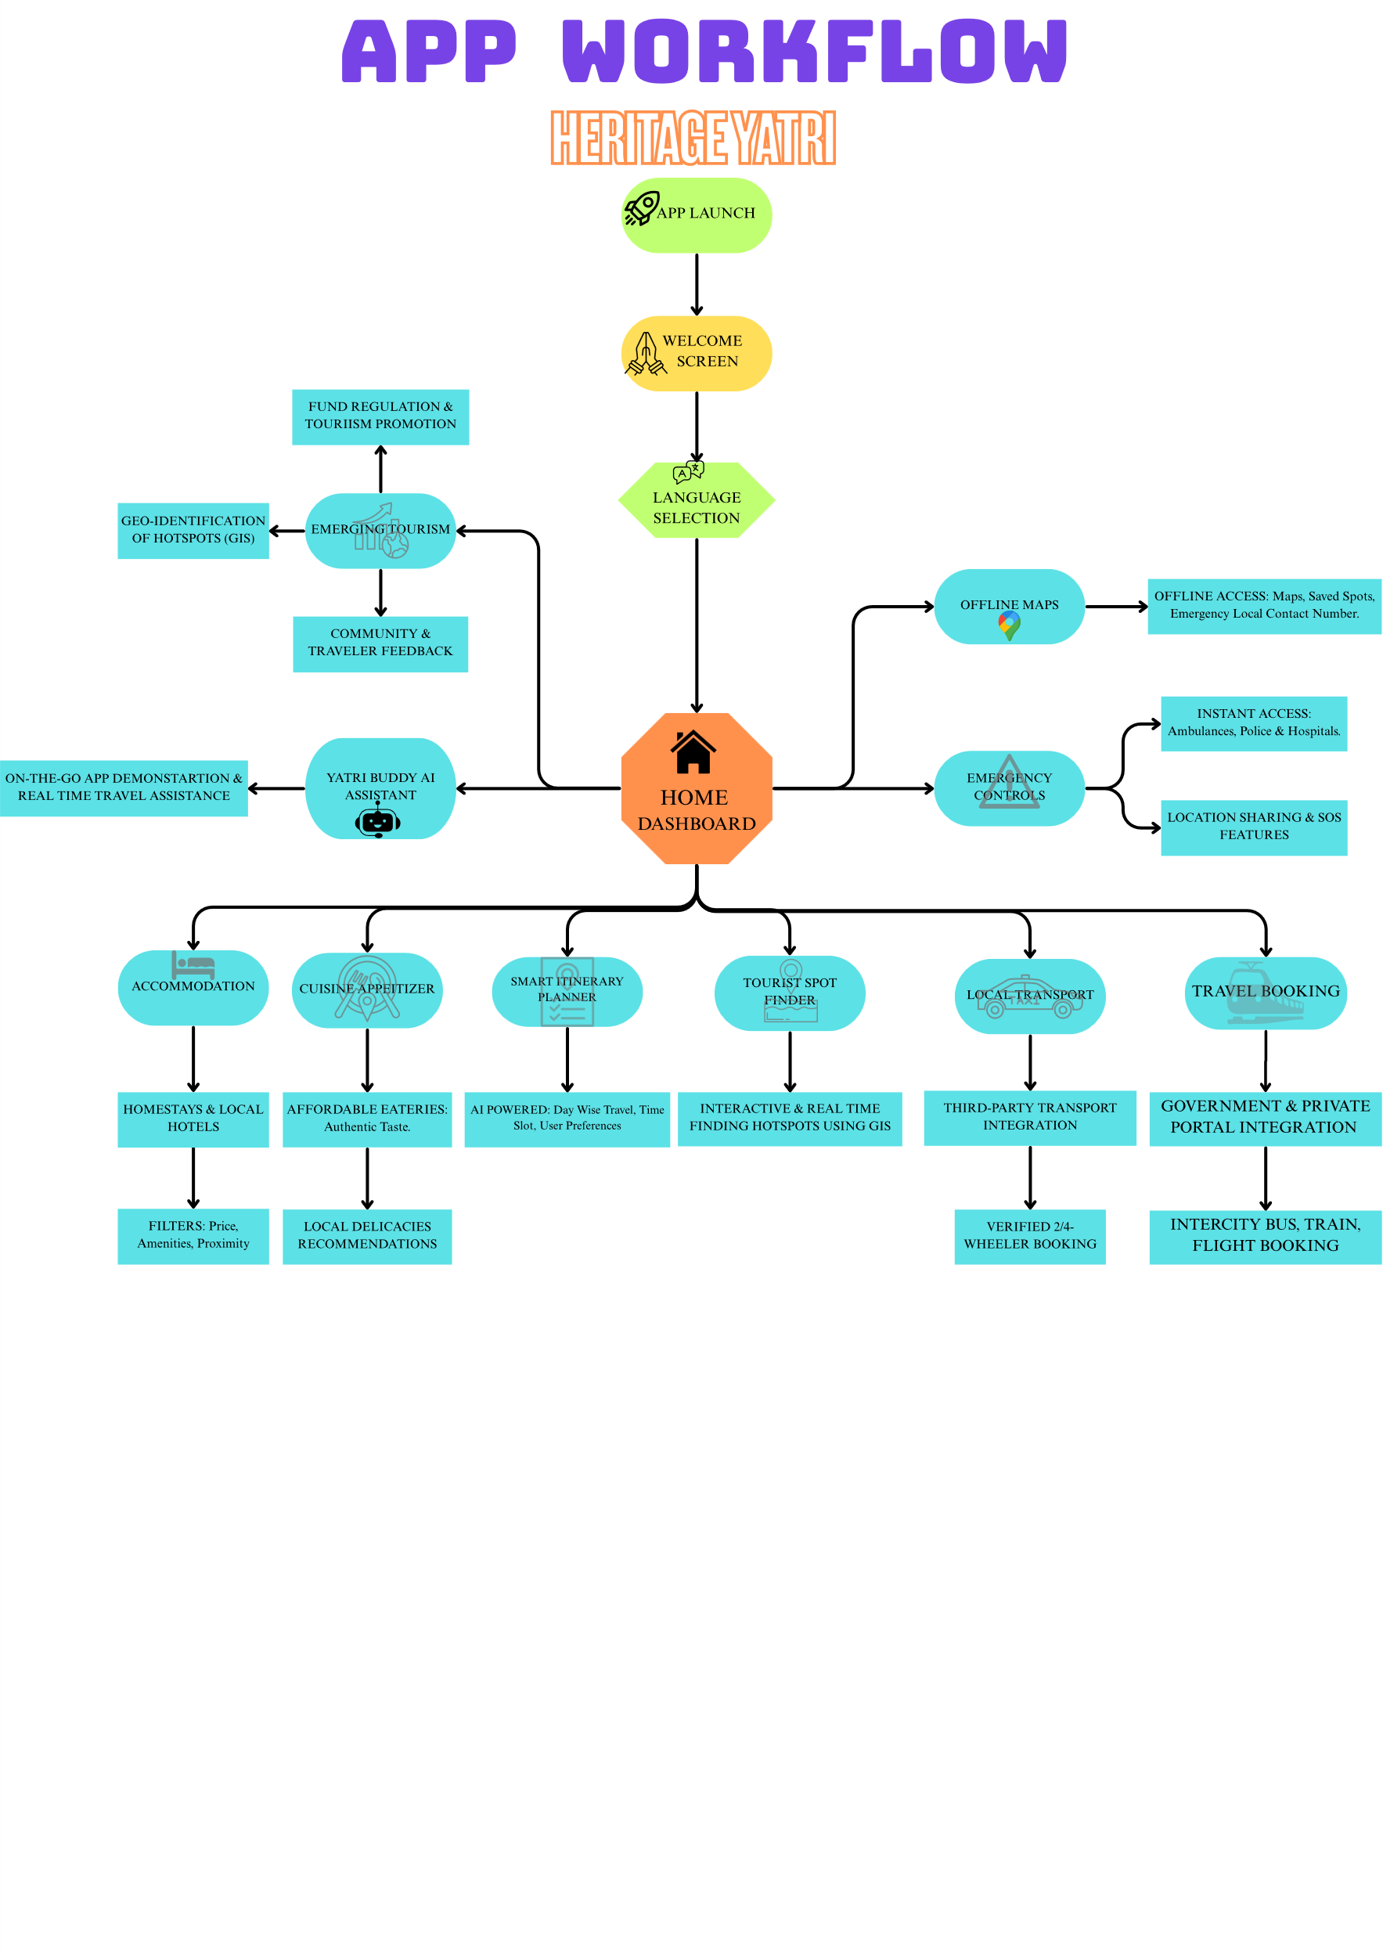

**App Features Overview of HERITAGE YATRI:**

HERITAGE YATRI combines innovation, cultural depth, and digital convenience to craft a seamless journey for every traveller. The app integrates essential travel components with an intuitive user interface and localized insights, ensuring that users experience both ease and authenticity while exploring any destination.

**Key Features**:

**• Tourist Spot Explorer:** Discover iconic landmarks like Harishankar, Aapkhol waterfalls, 64-yoginis temple, Hirakud dam and hidden treasures like Yudhistir Setu, Braj Dham mini waterfall, etc, with an interactive map. Each location includes cultural background, historical significance, visitor tips, and real-time navigation—all curated to make exploration insightful and efficient.

**• Accommodation Finder:** Browse a curated list of budget hotels, home-stays, and hostels. Use filters for price, amenities, and proximity to key attractions. Real-time availability and third-party booking integration ensure a smooth and economical stay.

**• Cuisine Discovery:** Immerse yourself in the region’s traditional flavours. Get recommendations on local delicacies, with suggestions for the best and most affordable eateries that serve them bringing authentic taste to your fingertips.

**• Local Transport Services:** Connect with verified cabdrivers and local rental agencies. Book two-wheeler or four-wheeler and access third-party transport services all integrated within the app for safe and convenient city movement.

**• Emergency Support:** Prioritizing tourist safety, the app includes instant access to emergency contacts ambulance, police, and nearby hospitals. Location sharing and SOS features offer real-time help in critical situations.

**• Travel Ticket Booking:** Book long-distance journeys without switching apps. Whether it’s train, flight, or bus, HERITAGE YATRI integrates government and private portals to streamline travel planning.

**• Smart Itinerary Planner:** Powered by AI, this tool customizes travel schedules based on user preferences, time constraints, and budget. From monuments to meal stops, get a day-wise travel blueprint tailored just for you.

**• Multi-language Support:** Break language barriers with built-in support for English, Hindi, and Odia(by default language) enabling a localized experience for every user. Additional language packs can be introduced as the platform expands.

**• Offline Mode:** Designed for travellers in remote or low- network areas, this feature provides offline access to essential travel info like maps, saved spots, emergency contacts, and directions ensuring you’re never stranded.

**Introduction of AI Travel Assistant – “YATRI BUDDY”**

To make travel even smarter and more personalized, HERITAGE YATRI introduces **“YATRI BUDDY”**, an AI-powered assistant designed to guide and support users throughout their journey.

**Key Features of YATRI BUDDY:**

* **On-the-Go Assistance**: Whether it’s booking a cab, checking hotel availability, or finding the nearest restaurant, YATRI BUDDY can assist users with quick features anytime during their travel.
* **App Demonstration and Support**: New users can interact with YATRI BUDDY to learn how to use different app features. It can explain the app’s services in a simple, step-by-step way to ensure a smooth experience for everyone.
* **Real-Time Travel Insights**: While travelling, the AI assistant provides interesting facts, historical importance, and cultural significance of the places being visited. This turns every journey into a rich learning experience.
* **Voice and Text Interaction**: Users can chat or talk to YATRI BUDDY, making it accessible to people of all age groups.

**Identification and Promotion of Emerging Tourist Hotspots:**

To further enhance the cultural and economic impact of HERITAGE YATRI, a dedicated module will be introduced to identify, develop, and promote potential tourist hotspots across rural and semi-urban regions of Balangir, Odisha and beyond. This module aims to spotlight natural, cultural, and lesser-known heritage locations that hold untapped tourism potential.

**Core Functions:**

* **Geo-Identification of Hotspots:**

Use of geo-tagging, crowdsourced data, and satellite mapping (via GIS integration) to locate and list potential tourist-worthy places such as waterfalls, caves, tribal cultural zones, seasonal fairs, and eco-sites.

* **Community & Traveler Feedback Integration:**

Enable users and local residents to suggest or highlight unique destinations through in-app submissions with photos, descriptions, and user ratings.

* **Government Collaboration Framework:**

Curated data from these identified locations will be periodically shared with the Tourism Department and relevant local authorities to recommend developmental interventions such as infrastructure improvement, hygiene facilities, eco-trails, and safety measures.

* **Fund Regulation and Monitoring (Govt. Assisted):**

HERITAGE YATRI will support a liaison feature that tracks and reports on government fund utilization (for transparency) toward infrastructure upgrades, hospitality training for locals, and green tourism promotion.

* **Tourism Promotion Toolkit:**

Once a site is officially acknowledged for development:

* + AR (Augmented Reality) enhancements will allow users to virtually experience such spots.

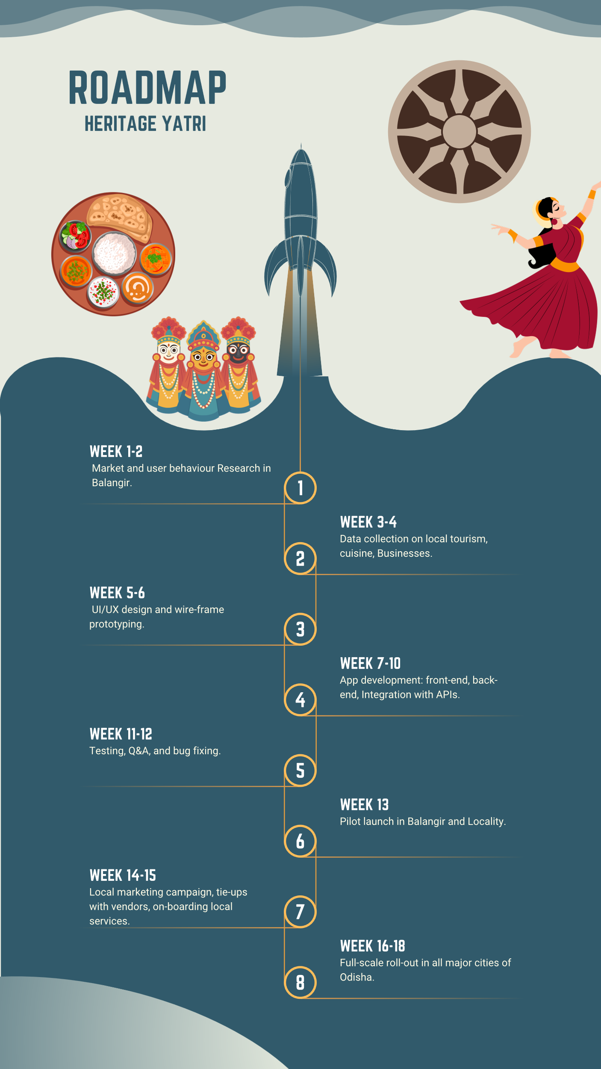

**Technical Architecture**

The technical foundation of HERITAGE YATRI is designed for performance, security, and scalability. Leveraging modern development frameworks and secure cloud architecture, the app ensures fast and reliable performance across devices. The back-end is built with flexibility to support real-time data, dynamic content rendering, and third-party integrations, making the application adaptable to a wide range of user needs.

• **Frontend:** Flutter/React Native for mobile responsiveness.

• **Back-end:** Node.js or Django with PostgreSQL.

• **API Integrations:** Google Maps, Booking.com, IRCTC, MakeMyTrip, Zomato, Ola/Uber, Odisha tourism.

• **Security:** Two-factor authentication, SSL encryption, secure data storage.

**Revenue Model**

HERITAGE YATRI follows a diversified revenue strategy to ensure sustainability and profitability. The app not only earns through direct user engagement and service facilitation but also through strategic partnerships and promotional opportunities for local businesses. The model is designed to create value for users while monetizing the ecosystem without hampering user experience. it includes:-

• **Commission from ticket/hotel/transport bookings.**

• **Premium listing and advertisement fees from local businesses.**

• **Freemium model with premium travel planning tools.**

• **Partnership with government tourism departments for infrastructure deployment.**

**Conclusion**

HERITAGE YATRI is not just an app—it is a vision to redefine how tourists experience destinations while uplifting local communities and promoting regional heritage. By bringing all critical travel services under one roof, the platform eliminates digital clutter and streamlines the travel experience with elegance and simplicity. Whether it’s discovering hidden gems, booking affordable stays, enjoying authentic cuisine, or ensuring emergency support, HERITAGE YATRI empowers users at every step of their journey. Its scalable architecture, inclusive design, and collaborative ecosystem make it a future-ready solution aligned with national tourism goals and digital transformation agendas. In a world where experiences matter more than ever, HERITAGE YATRI ensures that every tourist travels smarter, safer, and deeper—connecting not just with places, but with culture, people, and purpose. It is not merely a tool, but a trusted companion on the road to discovery.